
TryHackMe MrRobot CTF Writeup
CTF Writeup and Solution

Assessor Name: Waseem Kamal Al-Dawoud
Title: Cybersecurity Trainee at Green Circle
Contact E-Mail: waseemaldawoudpro@gmail.com

Executive Summary: On 24th of August, 2025. Waseem was tasked to submit a CTF writeup report about Tryhackme’s MrRobot challenge. The CTF revolves around web enumeration and wordpress exploitation. Waseem successfully completed the challenge and reached root level access on the server, hijacking the system. Report submitted on 11th of September 2025.

Approach: For this task, we’ll be following the cyber kill chain to better plan our attack, we are also going to be splitting this objective into 5 stages (Reconnaissance, Scanning & Enumeration, Exploitation & Weaponization, Installation, Command & Control, Privilege Escalation). Each stage will serve a purpose or an objective to accomplish.

Scope
IP/Host Address: 10.10.251.216
Description: A website that uses Wordpress CMS.

Assessment Overview

Stage 1: Reconnaissance
For the reconnaissance stage, Waseem gathered information about the target using tools such as Nmap and website discovery.

Stage 2: Scanning & Enumeration
Later, he used aggressive scanning methods with tools such as GoBuster, Nikto and WPScan for full enumeration.
Upon finishing, Waseem discovered a list of hidden directories, files and an admin page. He also discovered that the website uses wordpress Content Management System (CMS) which contains vulnerable plugins that could be weaponized and exploited. First, Waseem explored the hidden web pages such as ‘robots’ which is a webpage that is used to prevent search engines from indexing sensitive pages for the site (such as admin login pages), Waseem finds 2 more hidden paths (fsocity.dic, key-1-of-3.txt). Fsocity appeared to be a massive wordlist that can be used in brute force attempts (for password/username guessing).

Waseem also discovered an extraordinary string in ‘/licenses’ webpage, which appears to be a password of some kind. He saved it for another purpose in the future. Note: I forgot to mention that the text is actually a base64 encoded string, you need to decode it first.

Stage 3: Exploitation & Weaponization
Moving forward, Waseem finds out that the wp-login.php page is exploitable and vulnerable to brute force attacks. For this task, we used hydra tool to enumerate user accounts on the site. We discovered the “Elliot” user account. Next, Waseem tried to log into that account using the password he discovered earlier and it was a success.
Stage 4: Command & Control
Once inside the site administrator panel, we needed to establish a reverse shell for our Command & Control stage. Waseem prepared a malicious plugin script that can be uploaded as a wordpress plugin. Using the admin account, he was able to upload the plugin with no issues. Waseem started a listener and triggered the reverse shell, he was inside the system.

Stage 5: Privilege Escalation
At this point, our goal is now to fully hijack the system by reaching root access. But first we would need to break out of our limited shell as the user daemon had little to no privileges. Upon reading /etc/passwd, Waseem discovers the existence of user ‘robot’, so he browses /home/robot directory and sees an MD5 hashed password stored in a text file, presumably for the user robot. Using JohnTheRipper tool and the ‘fsocity.dic’ wordlist, Waseem was able to crack the password and set his user to robot.

However, we are not done yet. Our next step is to run basic Linux privilege escalation commands to determine vulnerabilities or misconfigurations that could lead to root access on the system. Waseem finds out /usr/local/bin/nmap is runnable with root privileges with the user ‘robot’. He checks the GTFO Binaries Website. He uses the nmap binary to break out from restricted environments by spawning an interactive system shell. He was now interacting with the system as root.

Step-by-Step Walkthrough
Reconnaissance (Passive and Active)
- Got an ip address? What is it? `nmap -sV <machine ip>`
- It has HTTP/S and SSH ports open? Let's see what this website is about.
- Maybe there are hidden directories? Follow [[Web Enumeration]] tactics to find out.
- `Robots` seems interesting. We can also check ‘/licenses/’ page which would give us the password for our user.

Scanning & Enumeration
- The site owner doesn't want us to access `fsocity.dic` and `key`, obviously here's your first key.
- ‘fsocity.dic’ seems to be a wordlist, maybe I should use this instead of `rockyou.txt` and others...
- When we conducted web enumeration using tools such as `GoBuster` we found out this page has a wp-login page.
- But what account should we use? Let's use the wordlist to enumerate user accounts.
- Before using `hydra` we need to understand how we can craft HTTP POST requests that would abuse the lack of security and therefore we open `burp` and turn on intercept, we send a test login post request and study how the request is sent.

Login Page Exploitation & Enumeration
- Once done, we now can use hydra to enumerate user accounts.
- We discover the user account `Elliot`, let's try combining that with the password we discovered in /licenses. Note: I forgot to mention that the text is actually a base64 encoded string, you need to decode it first.
- We now have access to the site administrator panel.

Second Stage Exploitation
- It's time to start a reverse shell with the server, there are many ways to do that with WordPress. However, the way I personally did it is by writing a malicious plugin code to be uploaded on the server.
- Make sure to set the client IP address and the port. Set up a listener.
- Activate the plugin and trigger the reverse shell, you should now be inside the system.

Privilege Escalation
- I began to conduct recon and info gathering, I discover the existence of user `robot`. There's also a `robot` directory which the permission is set to read only by robot, I also was able to see it had a key inside and a MD5 hash password stored in a text file.
- Time to crack the hashed password, I used `john` and the `rockyou` wordlist for this task.
- You may also consider stabilizing your shell before setting your user to Robot.
- We set our user to robot.
- We can now grab our second key here. However, we're not done yet.
- We now have to search for an exploitable binary that can be run by the user ‘robot’. For this, follow basic privilege escalation enumeration commands.
- We discover `/usr/local/bin/nmap`
- We can break out of the restricted shell by exploiting the nmap binary, allowing us to interact with the system as root.

Screenshots
Nmap Scan
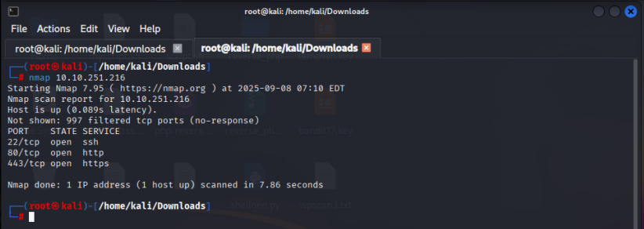
GoBuster Directory Enumeration
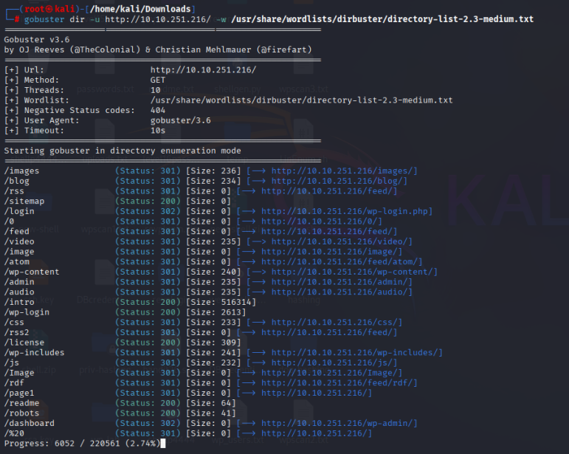
Nikto scan and website discovery
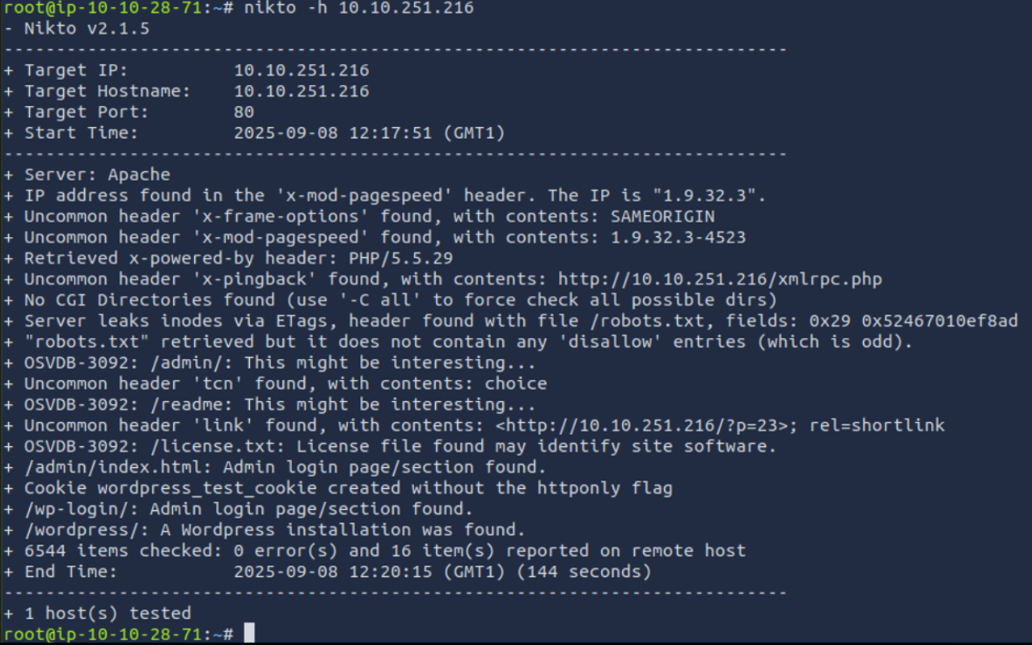
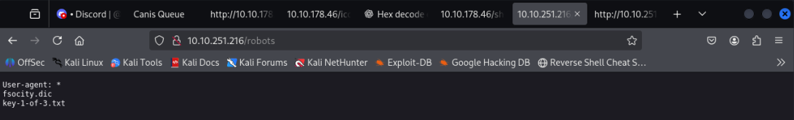

Using Hydra to enumerate user accounts on the wordpress login page
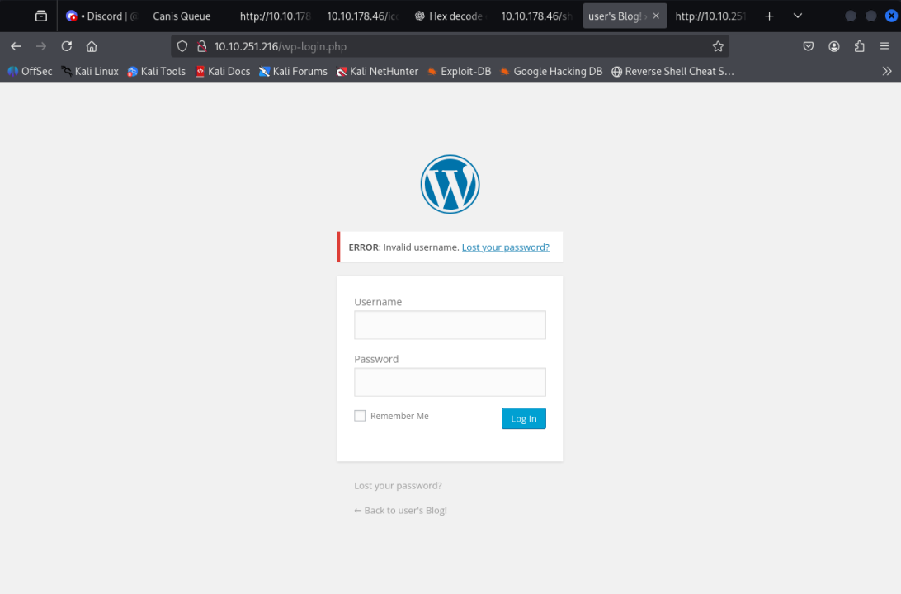
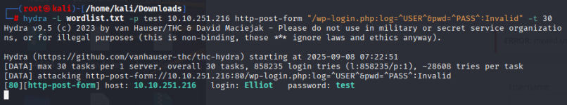

Decoding password using base64 and logging in
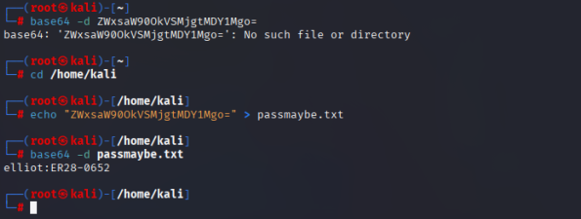
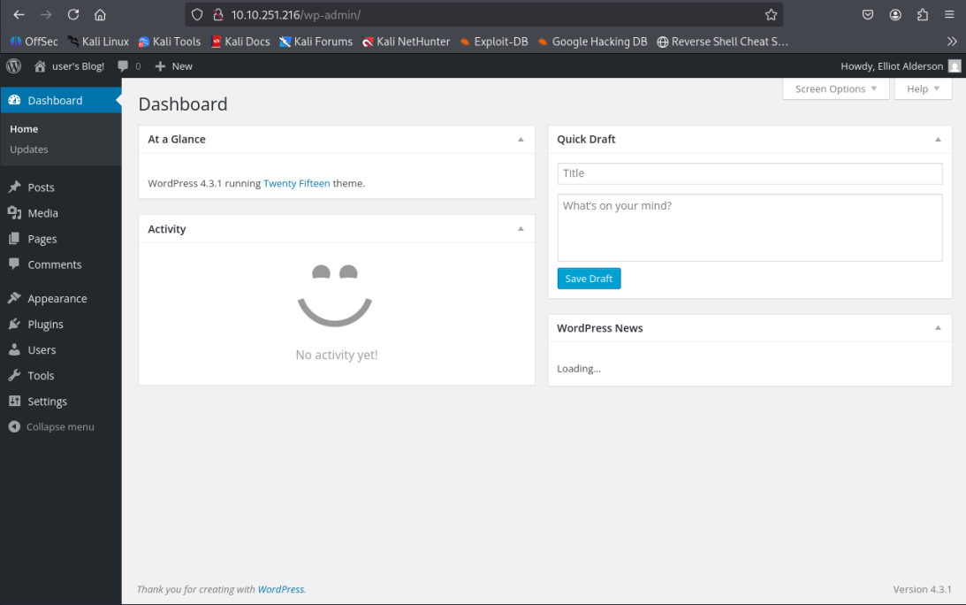

Creating a malicious reverse shell plugin code.
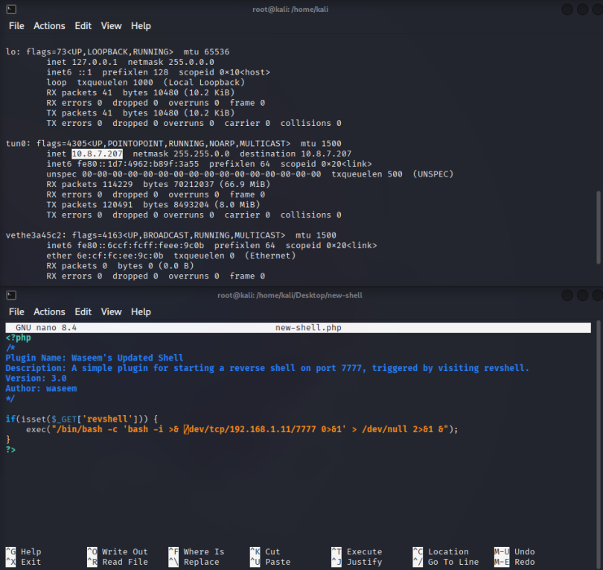
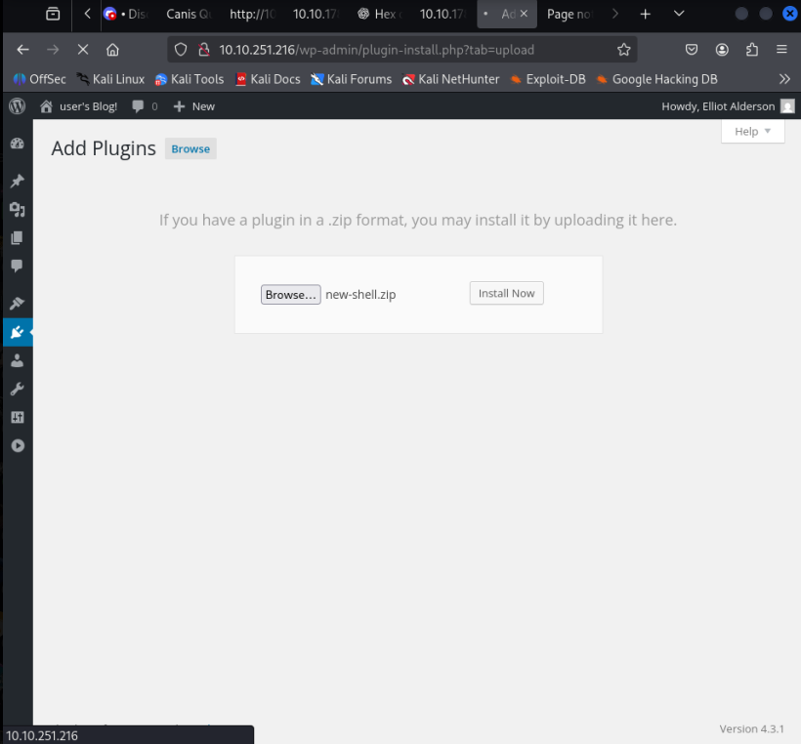
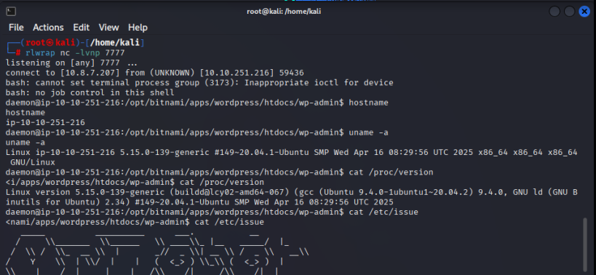

System Information Gathering as daemon.
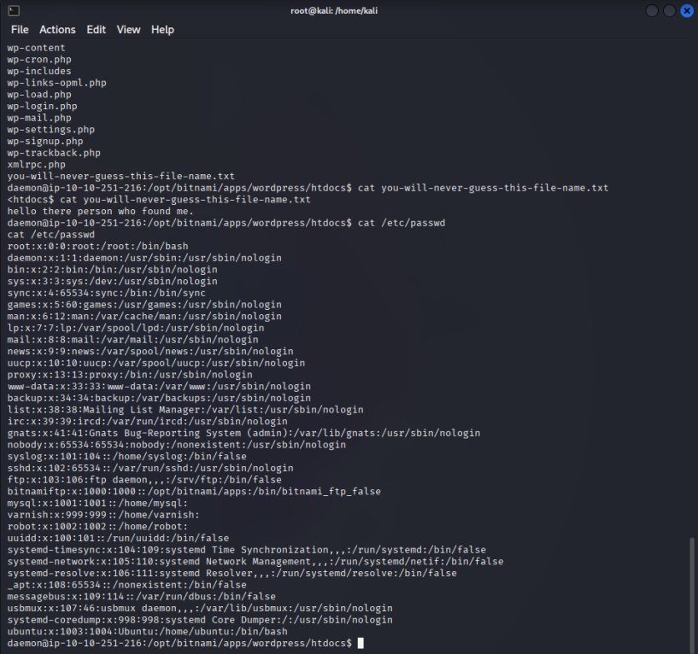

Discovering a ‘robot’ user and cracking an MD5 hashed password.
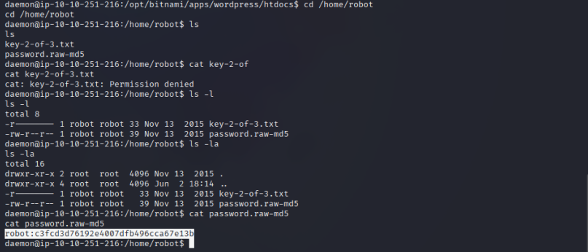
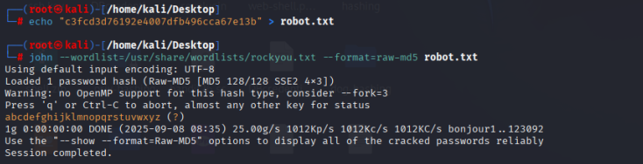

Exploiting nmap binary to break out of restricted shell and interact as root.
